Hydroelectricity Power Production Prediction
Using Machine Learning

Saurav Sabu CB.EN.U4EEE23032
Amrita Vishwa Vidyapeetham cb.en.u4eee23032@cb. students.amrita.edu
Thilak V N CB.EN.U4EEE23041
Amrita Vishwa Vidyapeetham cb.en.u4eee23041@cb. students.amrita.edu
Udaykrishna R CB.EN.U4EEE23042
Amrita Vishwa Vidyapeetham cb.en.u4eee23042@cb. students.amrita.edu
Neeraj T M CB.EN.U4EEE23052
Amrita Vishwa Vidyapeetham cb.en.u4eee23052@cb. students.amrita.edu

Dr.M.VenkateshKumar
Assistant Professor (SG)
Electrical and Electronics Engineering,
Amrita Vishwa Vidyapeetham,Coimbatore
m_venkateshkumar@cb.amrita.edu

Abstract— Harnessing into the power of water has enhanced renewable energy sector, but prediction of hydropower energy with accuracy remains a challenge. Accurate Prediction of the power generation is very difficult to enhance power distribution,to reduce energy waste,with improved efficiency. The study of hydropower generation rely on machine learning which predicts the turbine efficiency and power output. The dataset contains water flow rate,water head height,dam height,and dam length.This model is trained using random forest, because this provides higher accuracy to predict turbine efficiency based on the inputs. A random forest model is used for training dataset because of the robustness while handling the complex and non linear relationships of the dataset and the ability it has to provide higher accuracy compared to other regression techniques. This project shows the application of machine learning in renewable energy systems by providing an accurate method for predicting efficiency of the turbine and thereby the power generation. This results helps to enhance the hydropower plant operations.
[Keywords:Renewable energy,efficiency,flow rate,head height]

Introduction
Hydropower generation is affected by various environmental and other parameters which leads to power inefficieny and power wastage. Thus, precise prediction is crucial for effective power management . The Polynomial Regression method, in machine learning techniques, is used in this project to predict hydropower in a hydroelectric facility.Various real time parameters including water flowrate, water head height and efficiency of the turbine are used in training of the model. Random forest is used to improve prediction accuracy as it can process non linear realtionships effectively.
This enhances decision making for resource optimisation and proves to be better than conventional techniques as shown by experimental findings.

Hydroelectricity-Basics

Hydroelectricity is a renewable form of energy which converts one form of energy into electrical energy.Water flowing from a height ‘h’ is having high potential energy.As the water starts flowing from this height the gravitational potential energy is slowly converted to kinetic energy and as the water reaches the bottom point the whole mechanical energy is contributed by kinetic energy alone.This kinetic energy is utilised to rotate the turbine blades thereby creating rotational mechanical energy.The turbine drives a generator,converting mechanical energy into electrical energy .A part of the energy is lost during the process due to friction and turbulence.
It is considered one of the efficient and reliable method of energy production and 15% of the global electricity is given by hydroelectricity alone.The efficiency of the hydroelectricity generation depends on the weather conditions,hydrological variables and seasonal changes,which indicates that a robust predictive models necessary for optimal energy management.
These are the operations taking place in a hydroelectric power plant:
Dams and Reservoirs:These structures maintains water flow and acts as a controlled supply to the system.
Penstocks:These are pipes which carry water from reservoirs to the turbines.These pipes maintains water flow.pressure and helps in generating electricity by directing water to the turbines
Turbines:Rotating blades which convert hydraulic kinetic energy into rotational mechanical energy.
Genrators:These are electromagnetic devices which converts the mechanical energy into electrical energy/power via electromagnetic induction.
Transformers and Transmission Lines:Convert generated electricity to appropriate voltage levels based on the needs and transdmit it to users through power grids.

The output power of a hydroelectric plant is given by the equation:
$P=η⋅ρ⋅g⋅H⋅Q$ (1)

where P is the output power(watts),η is the efficiency,ρ is the density of water (kg/m³),g is the acceleration due to gravity ,H is the water head(m),Q is the flow rate (m³/s)
The accuracy of the hydroelectricity is necessary to grid stability,efficient water resource management and energy trading.Machines learning techniques like Random forest can be used to analyse old data and predict future output power on environmental and operation parameters.
This report explores the basics of hydroelectricity power generation and the implementation of Random forest for hydroelectricity prediction, and the issues faced due to the absence of predictive modelling.
Drawbacks without prediction:These are issues faced due to the lack of monitoring old data and prediction:
Grid instability:Changes in river discharge and water levels lead to unpredictable fluctuations in power generation,causing voltage instability and frequency deviation in the grid.
Economic Disruptions:Unplanned variations in output power affects energy pricing increasing financial risks for utility providers.
Environmental and Ecological Impacts:If the water level is not properly maintained it can lead to habitat disruption affecting aquatic biodiversity and downstream water availability for irrigation and human consumption.
Inefficient Water resource utilization:Improper water level prediction causes inefficient water use and possible waste.

Traditional prediction methods
Traditional Hydropower generation prediction methods has been performed using statistical models and physics-based (hydrological) models. Statistical models use historical data and mathematical relationships. Polynomial Regression attempts to model nonlinear relationships but is prone to less accuracy. Models like Seasonal ARIMA (SARIMA) and Autoregressive Integrated Moving Average (ARIMA) analyse past values and its patterns to predict power generation. While useful for short-term forecasting, these models assume data being constant/linear making them unreliable when environmental conditions fluctuate.
Physics-based models uses mathematical equations derived from fluid mechanics, thermodynamics, and energy conservation laws. Models like SWAT (Soil and Water Assessment Tool) and HEC-HMS (Hydrologic Modeling System), predict river discharge and reservoir inflow based on precipitation characteristics. These models may be good for long-term water resource management but require detailed meteorological and hydrological input data which may be hard to collect at times.

Block Diagram
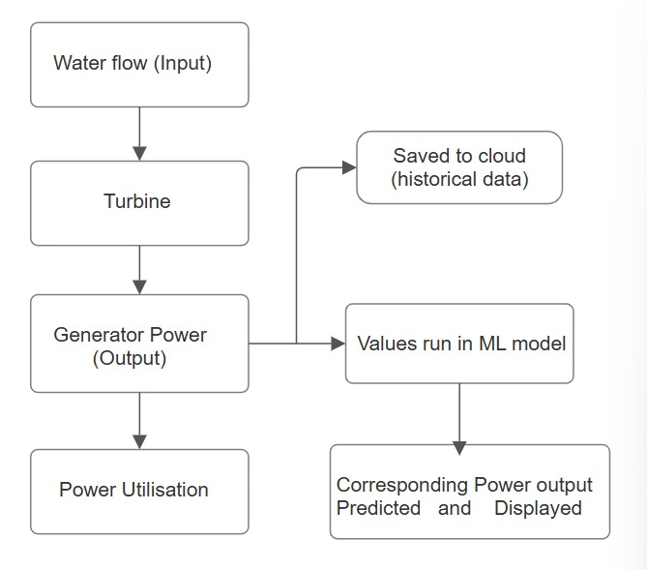
Figure 1:Block Diagram of flow of process
The block diagram shows how hydropower plants can produce electricity and how machine learning (ML) is used into the system to improve efficiency of the model.
Water Flow Rate: The primary input for electricity generation in a hydropower plants. This water is usually obtained from a dam, or reservoir. The amount of water available and its flow rate shows how much electricity can be produced. This means that more water and faster flow produces more electricity.
Sensors can be used to measure the flow rate and send this data to a system which is analyzing. If the flow is low, modifications is needed to promote effective power generation.
Turbine:The turbine is a rotating machine which converts kinetic energy of water into mechanical energy. When water passing over the blades of the turbine causes them to spin like a fan. The turbine is connected with a shaft,it helps to transfer the energy to the generator. Different types of turbines are used in hydropower plants, depending on the height of the water head and rate of flow. The efficiency of the turbine shows how much power can be devoloped.
Generator Power (Output): The generator is the core part that produces energy. This is connected to the turbine, and as the turbine rotates, the generator also spins. Inside the generator, mechanical energy from the turbine is converted into electrical energy.The generator in a hydropower plant supplies electricity to homes, industries, and the power grid.
.Power Utilization:Once the electricity is produced, it should be used efficiently. The power produced is sent to a transmission system,distributes it to different places. A fraction of the energy is stored in batteries or used to control the electricity grid. In any given area, efficient power use guarantees that electricity is neither wasted nor overloaded. Power is distributed according to assistance of smart grid technologies.
Saved to Cloud (Historical Data):
Hydropower plants collect and keep information about flow of water, turbine speed, power output, and weather so as to enhance performance. Since this data is stored in a cloud-based system, it can be examined and reviewed at a later time. Because it enables engineers to analyze trends, about the amount of power generated during various seasons, historical data is important planning for future power generation and increasing efficiency can both improve with this information.

Values Run in ML Model: A machine learning model uses the kept data to generate estimates regarding future power output. Based on current water flow and other factors, ML models examine past trends and patterns to project how much electricity might be produced. For the same period next year, the ML model can forecast greater electricity generation if it finds, for instance, that water flow rises by 30% during the monsoon season. This enables operators to make required turbine and generator adjustments as well as to make ahead plans.Machine learning models used in this process can also include this methods:
Linear Regression:Predicts power output based on water flow.
Neural Networks:examines complex relationships between multiple parameters for better accuracy.

Power Output Predicted:
While monitoring the system, the power output expected is displayed after the ML model is trained. This helps plant operators see the expected power generation in real time.if the model predicts that low water flow will reduce power output in the coming days, operators can take early action. They can adjust turbine settings or plan for alternative energy sources in advance.This step improves planning, reduces energy waste, and makes the electricity supply more reliable.
The block diagram below shows how hydropower plants generate electricity and how machine learning improves efficiency. Unlike traditional methods that rely only on real-time data, ML allows us to predict future power generation and optimize performance.

About the turbine:
Francis turbine: Hydro power is generated by turbines, in mid to high level dams. A turbine called Francis turbine is used. Francis turbines have many advantages while we are using it in hydropopwer generation. It is used because of its huge efficiency and adaptability. This turbine a reaction turbine - they work by kinetic energy and water pressure energy. They are characterized by their inward flow radial design, which later transitions into an axial flow as it passes through the runner.
Francis turbines works on the principle of water flow to to mechanical energy conversion. Water enters into a spiral casing and flows through guide vanes that regulates the flow direction of the weather and velocity of the water. The entered water hits the curved blades of the runner which transfers the energy which causes the shaft to rotate, this rotation makes the generator to run which converts mechanical energy into electrical power.
Components of Francis turbines:
Spioral casing : directs water into the turbine
Guide vanes: Control water flow tonoptimize efficiency.
Runner:Conssits of blades which the water hits and helps to extracenergy
Draft tube: Reduced the speed of water which gets out and recovers pressure
Shaft: transmits mechanical power to the generator using bearings
We use Francis turbines because of its certain unique advantages :
It has very high efficiency, it typically ranges from 85 to 95 percent
Its is adaptable to waide range of head height conditions
Long lifespan with proper maintenance
Continuous and stable energy output.
Cost-effective in terms of power generation per unit
However, it has some challenges It Requires precise installation and maintenance. Susceptible to cavitation, which can erode turbine blades over time. Requires precise installation and maintenance.
Francis turbines plays a crucial role in modern hydropower generation because of its high efficiency and adaptability. It is used in many major dams in india also like tehri etc.During some time it works inversely also it works as a motor also sometimes which helps in pumping water to nearby irrigation sites and to some agriculture areas.This turbine is a multipurpose one.Researches are going on this turbines we can still expect some advancements in this francis turbines.

Methodology

Data Collection
Data acquisition is the first step to start a machine learning project. The data in the above project was obtained from Trusted internet sources and the remaining values are manually calculated by using formulas. The project code runs on a random forest model, which is used as a regression model and a classification model. The next step in the process is to clean the acquired data because the cleaner data gives more accurate values. Lakhs of raw data were collected and it got cleaned to a few hundred of data. While the data collection, the raw data contained the starting and ending time of the measurement of water levels and power generated by the turbines. We manually calculate the flow rate of the water using the dam's structural data. The water flow of the dam was calculated using a technique called Flow measurement using a weir or Flow measurement using a spillway, the technique uses a formula to calculate the water flow. The chosen dam uses Francis turbines, which are good for medium to high level dams. The cleaned data was split into a training and testing ratio of 75 to 25 percent. In order to elevate the accuracy of the classification model, a portion of the data in the datasets is used for training the model. It helps in increasing the accuracy of the model.

Polynomial regression

Advantages of random forest include ,
Polynomial regression is a type of regression analysis where the relationship between the independent variable and the dependent variable is modeled in the _n_th drgeree. It is used in datasets where the relationship between features has a non linear rea;tionship . The polynomial regression is the best to use in this regression model because of its very good and high r² valure which is nearly 0.99. It is also used in cases when a simple linear regression model fails to capture the trend in the data. It is used because of its reliability and it can model more complex relationships than linear regression
Polynomial Regression has many advantages,making it a suitable technique for creating complex relationship between variables.Unlike linear regression which consider a linear relationship between input variable and the target variable,polynomial regression helps us to makes non linear patterns by adding higher degree polynomial terms.This reduces overfitting of datasets and easily helps to fit the datasets where the relationship of the variables is not linear,increasing the accuracy of predicted values.
Apart from that polynomial regression helps to reduce errors while creating a neutrality between overfitting and underfitting when properly tuned.It is more efficient both manually and computationally when compared to other machine learning models making it a good model for real life applications.
The data set used in this project/ machine learning algorithm consist of record from dams ranging through a certain height , the features of this datasets are effective head, water flow rate , dam height , dam length and turbine efficiency. This dataset was cleaned and preprocessed a number of times to remove all noises and irrelavent features in it this was done to make sure that only the needed things are available in the dataset. The dataset was checked was missing values and the missing values was handeled properly, then the data set was split into 80:20 ratio , which is 80percent to training and 20 percent to testing using train-test split method to ensure unbiased model evaluation. Many linraries from python like numpy ,pandas were used. To standardize feature scales and improve model perfomances Standardscalar from scikit learn library was used in the dataset to transform it.This ensuresd that all input variavles had a mean of zero and a unit variance which prevents the feature from disproportionately influencing the predictions
Four different machine learning models were used to predict the turbine efficiency. Polynomial regression with degree 2 was used ,Random forest regressor ,Support vector Regressor was used and K-Nearest Neighbors (KNN) 5 was also used here in this model to predict the op power with great accuracy. These models were chosen based on their ability to capture different types of relationships between the input features and turbine efficiency.Polynomial Regression with degree 2 was used because of the non linear relationship between the datasets. Random forest- 100 decision trees was used to capture complex things and improve prediction accuracy. KNN Regressor was implemented with k=5, making predictions based on the nearest data points in the training set. SVR - support vector regressor which is same ad support vector mechanism , the difference is svm classifies the data wgere svr predicts the data classification and prediction is the major difference between SVM and SVR

$MAE=\frac{1}{n}\sum{\left|y_{true}-y_{pred}\right|}$ (2)
$RMSE=\sqrt{\frac{1}{n}\sum{({y_{true}-y_{pred})}^{2}}}$ (3)

$R^{2}=1- \frac{\sum{(y_{true}-y_{pred})²}}{\sum{{\left(y_{true}-\overline{y}\right)}^{2}}}$ (4)

Table 1:Model Perfomance Metrics
MODEL | MAE | RMSE | $$R^{2}$$
Polynomial Regression | 0.207272 | 0.264235 | 0.991623
Random Forest | 0.233488 | 0.302936 | 0.988989
KNN | 0.231100 | 0.294788 | 0.989573
SVM | 0.252791 | 0.317830 | 0.987880

R², MAE , RMSE these are the values which represents the accuracy of the dataset, The higher the R² value the accuracy is greater. The lower the value of RMSE and MAE the predicted vales are accurate. The model with the lowest RMSE was selected as the best-performing model for predicting turbine efficiency and hydroelectric power output.
The code was generated like ,the user should be giving the input and the model predicts the accuracy of it, it was done to ensure the compatibility with the trained model. The provided information which are inputs were standardized using the previously fitted scaler
The predicted turbine efficiency was then used to compute the hydroelectric power output using the standard formula:
where P is the power output in watts, η is the turbine efficiency in fraction, ρ is water density (1000 kg/m³), g is gravitational acceleration (9.81 m/s²), H is the effective head in meters, and Q is the water flow rate in cubic meters per second.

Equations
In hydroelectric plant,the output power obtained is totally depended on the water flow rate and the head height.These quantities influence the total mechanical energy of the water,which is later converted into electrical energy.
The water flow rate(Q) is given by the equation:
​
$Q=C_{d}⋅L⋅H^{3/2}$ (5)

Where ‘Cd’ is the discharge coefficient,’L’ is the wier length and ‘H’ is the head height.This equation accurately predicts water availability for power generation and also accounts for energy losses due to flow conditions.
The output power produced in hydroelectricity is given by the equation(1):

Where ‘η’ is the efficiency,’g’ is acceleration due to gravity,’Q’ is the water flow rate and ‘H’ is the head height.
These equations are the basis of hydroelectricity generation.By analyzing historial data with the help of machine learning can optimize power prediction and enhance the efficiency of hydroelectric plants.

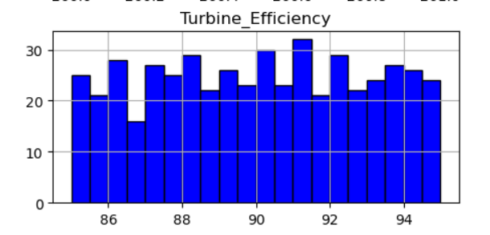
Figure 2:Feauture Distribution of Turbine Efficiency

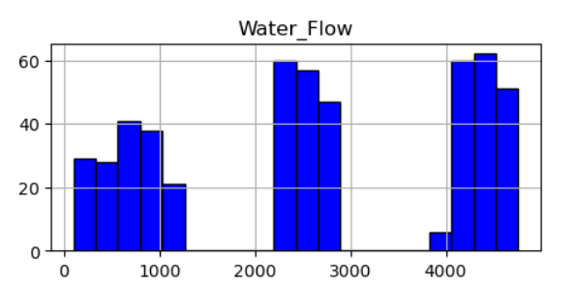
Figure 3: Feauture Distribution of Water Flow

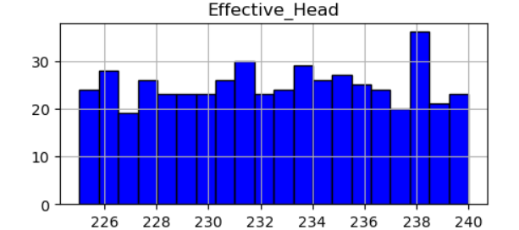
Figure 4: Feauture Distribution of Effective Head

Inference:

This model incorporates different regression techniques to predict turbine’s efficiency based on basic input like Water head and Water flow rate . Data preprocessing is done to the dataset by removing unwanted columns and splitting the whole dataset into 80% training and 20% testing. Polynomial Regression , Random forest , K-Nearest Neighbours(KNN) and Support Vector Regression (SVR) have been used and are trained using various metrics including Mean Absolute Error (MAE), Root Mean Square Error (RMSE) and R² score.Using all these parameters , Efficiency of the turbine is predicted and the Hydroelectric power is computed by Equation 1 . The results are visualized using bar graphs to show both the predicted efficiency and power output.

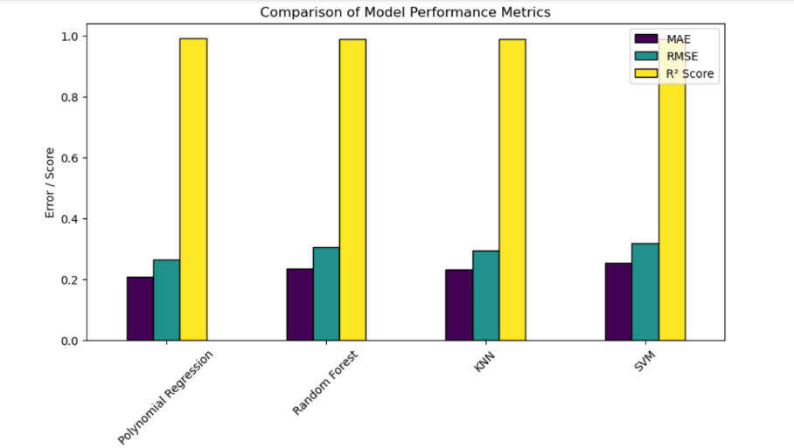
Figure 5: Comparison of model performance metrics

The random forest model which we trained has given the feature which is very important in the model – head height or effective head height . It refers to the height of water level in the dam. The data was calculated by the formulas and the data was expanded and studies using GAN model in python.
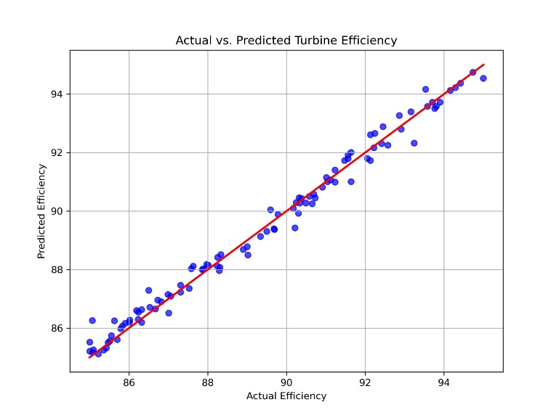
Figure 6:Actual vs Predicted Turbine efficiency

The predicted values are 94, 88, and 86. These values suggest that the model or method used for prediction anticipated the turbine's efficiency to be in the range of 86% to 94%. The actual efficiency values recorded are 96, 88, 90, 92, and 94. These values indicate that the turbine's real-world performance ranged from 88% to 96%.
The actual efficiency values are generally higher than the predicted ones, except for one instance where both predicted and actual efficiencies are 88%.
The highest actual efficiency (96%) exceeds the highest predicted efficiency (94%).
The lowest actual efficiency (88%) matches the lowest predicted efficiency
The prediction model seems to be conservative, as it underestimated the turbine's efficiency in most cases.

III.CONCLUSION:

This project showed how machine learning can help to improve the hydropower plants generate electricity. By predicting power output based on water flow,turbine efficiency, and plan for backup energy sources is also be needed.
Traditional methods can only use real time data, which will be hard to predict future changes in power generation. Machine learning helps to solve this problem by allowing us to see trends in advance, reduce energy waste, and keep the electricity supply more stable. This just dont makes power generation more reliable but also supports better management of energy.
By adding machine learning to hydropower plants is an good step to improve energy production. As technology is continously devoloping, these smart prediction of models will help make electricity generation more efficient, cost-effective, and environmentally friendly.

References
[1] J. K. Patel and S. R. Gupta, "Impact of Climate Change on Hydroelectric Power Generation: A Case Study," 2020 IEEE International Conference on Renewable Energy Research and Applications (ICRERA), Glasgow, UK, 2020.
[2] A. K. Sharma, R. Singh, and P. K. Mishra, "Optimization of Small Hydropower Plant Using Machine Learning Techniques," 2022 IEEE International Conference on Power Electronics, Smart Grid, and Renewable Energy (PESGRE), Trivandrum, India, 2022.
[3] H. Zhang, Y. Liu, and X. Wang, "Hydroelectric Power Forecasting Using Deep Learning Algorithms," IEEE Transactions on Sustainable Energy, vol. 12, no. 4, pp. 765-774, Dec. 2021.
4] L. Wang, "Modeling and Simulation of Hydro-Turbine Governors for Efficient Power Generation," 2019 IEEE International Conference on Power Systems Technology (POWERCON), Beijing, China, 2019.
[5] W. Chen, "Integration of Hydropower with Smart Grids: Opportunities and Challenges," IEEE Transactions on Power Systems, vol. 14, no. 3, pp. 987-995, Sept. 2020.
[6] M. S. Rahman and T. Ahmed, "Performance Analysis of Hydroelectric Power Plants Using Predictive Models," 2021 IEEE International Conference on Sustainable Energy and Future Electric Transportation (SEFET), Chennai, India, 2021.
[7] P. R. Sharma and K. N. Verma, "A Review on Efficiency Improvement Strategies in Hydroelectric Power Plants," 2021 IEEE International Conference on Energy, Environment, and Sustainable Development (EESD), New Delhi, India, 2021.
[8] S. Das and R. Banerjee, "Hydroelectric Power Generation Potential and its Impact on Grid Stability," 2020 IEEE PES General Meeting (PESGM), Montreal, Canada, 2020.
[9] T. K. Roy, "Analysis of Hydro Power Plants for Sustainable Energy Generation," 2019 IEEE International Conference on Energy Efficient Technologies for Sustainability (ICEETS), Nagercoil, India, 2019.
[10] B. Singh and M. P. Sharma, "Hydropower Development in India: Challenges and Opportunities," 2022 IEEE International Conference on Smart Energy Systems and Technologies (SEST), Eindhoven, Netherlands, 2022.

.

